Triangle Inequality Theorem

Definition
# Source: AI Source: Provided by: [Data Path: Persons Table -> ID Column: 1, Name_En Column: Motasem Essam] -> From: [ChatGPT] on [7/25/2026]
The Triangle Inequality Theorem states that the sum of the lengths of any two sides of a triangle must be greater than the length of the third side.
For a triangle with side lengths:
$$a, b, c$$
the three triangle inequalities are:
$$\boxed{a+b>c} \\ \boxed{a+c>b} \\ \boxed{b+c>a}$$
All three conditions must be satisfied for the three lengths to form a triangle.
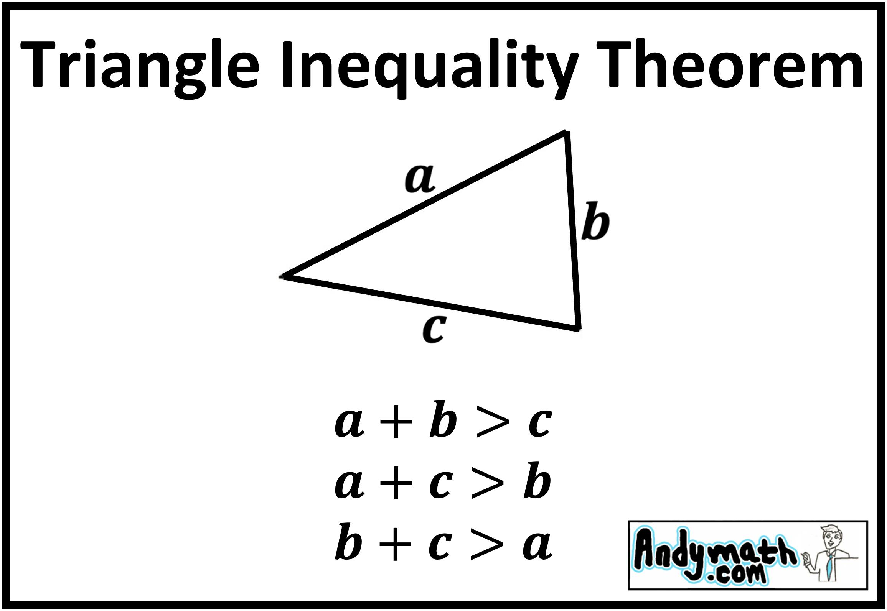
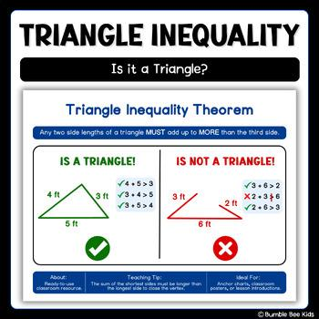
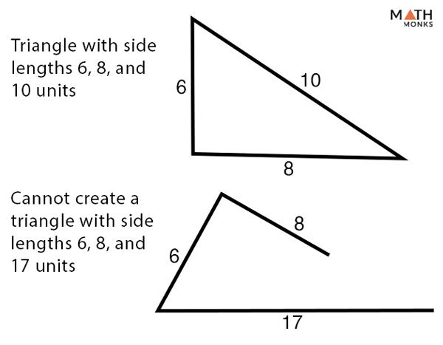
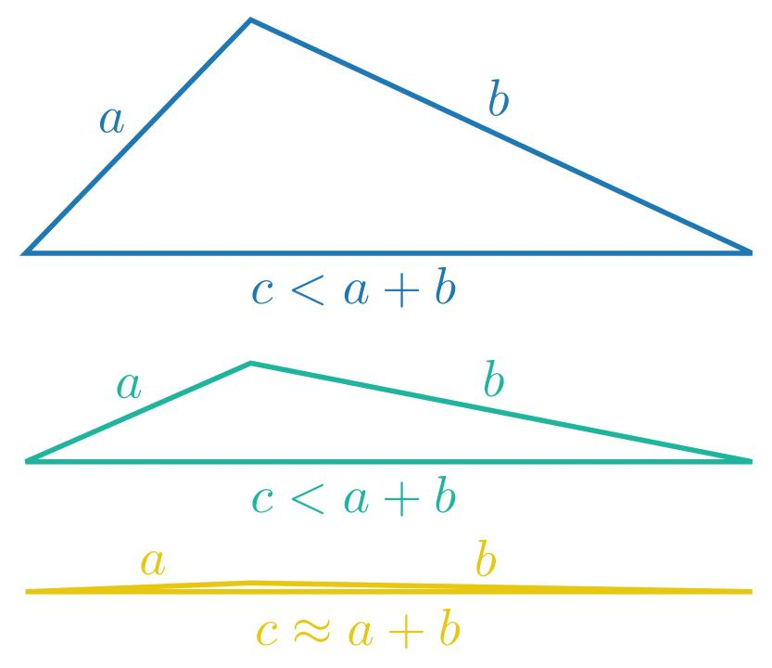

Purpose
# Source: AI Source: Provided by: [Data Path: Persons Table -> ID Column: 1, Name_En Column: Motasem Essam] -> From: [ChatGPT] on [7/25/2026]
The Triangle Inequality Theorem is used to:
- Determine whether three lengths can form a triangle.
- Find possible values for an unknown side.
- Establish relationships between triangle sides.
- Solve geometric problems.
- Analyze possible triangle constructions.
- Support coordinate geometry and trigonometry.
- Verify measurements in engineering and surveying.

Fundamental Idea
# Source: AI Source: Provided by: [Data Path: Persons Table -> ID Column: 1, Name_En Column: Motasem Essam] -> From: [ChatGPT] on [7/25/2026]
Consider a triangle with side lengths:
$$a, b, c$$
The two shorter sides must be long enough to reach each other and form a closed figure.
Therefore:
$$\boxed{\text{Sum of any two sides}>\text{third side}}$$
For example, if:
$$a=5, b=6, c=8$$
then:
$$5+6>8 \\ 11>8 \\ 5+8>6 \\ 13>6 \\ 6+8>5 \\ 14>5$$
All three inequalities are true, so the lengths can form a triangle.

Mathematical Representation
# Source: AI Source: Provided by: [Data Path: Persons Table -> ID Column: 1, Name_En Column: Motasem Essam] -> From: [ChatGPT] on [7/25/2026]
For side lengths $a,b,c$:
$$\boxed{a+b>c} \\ \boxed{a+c>b} \\ \boxed{b+c>a}$$
An equivalent and often more convenient form is:
$$\boxed{∣a-b∣<c<a+b}$$
This form gives the possible range of the third side when two sides are known.

Why Must the Sum Be Greater?
# Source: AI Source: Provided by: [Data Path: Persons Table -> ID Column: 1, Name_En Column: Motasem Essam] -> From: [ChatGPT] on [7/25/2026]
Imagine two sides of a triangle with lengths:
$$a=4, b=5$$
The third side must be long enough to connect their endpoints.
If:
$$c=3$$
then:
$$3+4>5 \\ 7>5$$
so the triangle can exist.
But if:
$$c=9$$
then:
$$4+5>9$$
becomes:
$$9>9$$
which is false.
The sides would form a straight line rather than a proper triangle.
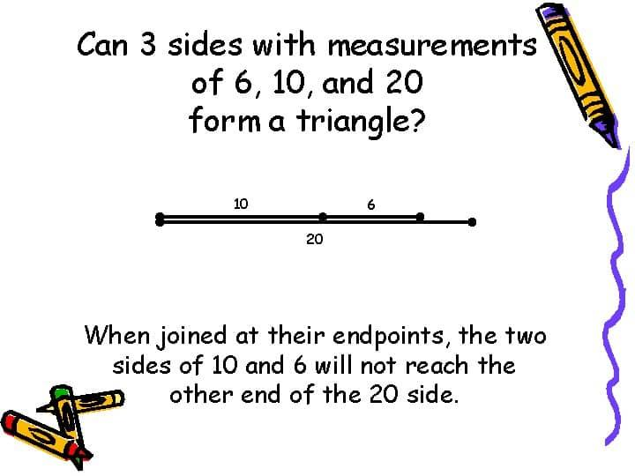
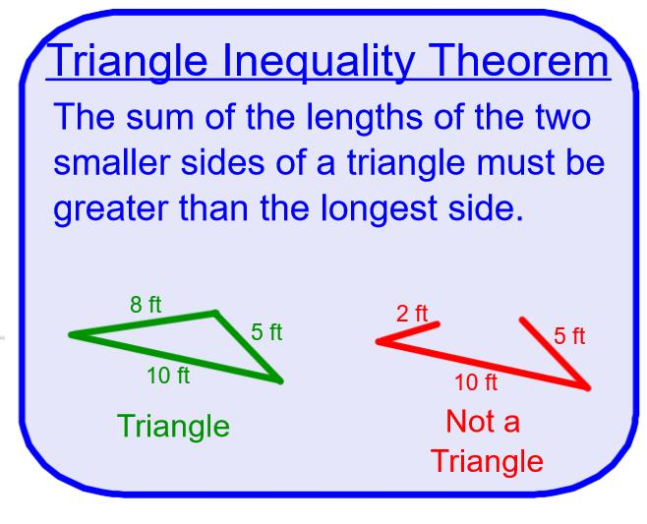
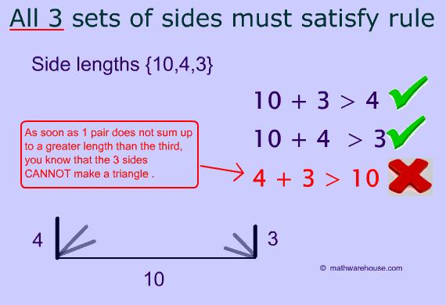

Strict Inequality
# Source: AI Source: Provided by: [Data Path: Persons Table -> ID Column: 1, Name_En Column: Motasem Essam] -> From: [ChatGPT] on [7/25/2026]
Notice that the theorem uses:
$$\boxed{>}$$
not:
$$≥$$
For example:
$$3+4>7$$
is false because:
$$3+4=7$$
Therefore, $3,4,7$ cannot form a proper triangle.
They form a degenerate triangle, where all three points lie on one straight line.
Thus:
$$\boxed{a+b=c}$$
does not produce a proper triangle.

Example 1 — Can Three Sides Form a Triangle?
# Source: AI Source: Provided by: [Data Path: Persons Table -> ID Column: 1, Name_En Column: Motasem Essam] -> From: [ChatGPT] on [7/25/2026]
Consider:
$$5, 7, 9$$
Check the inequalities:
$$5+7>9 \\ 12>9$$
True.
$$5+9>7 \\ 14>7$$
True.
$$7+9>5 \\ 16>5$$
True.
Therefore:
$$\boxed{5, 7, 9\text{ can form a triangle}}$$

Example 2 — Cannot Form a Triangle
# Source: AI Source: Provided by: [Data Path: Persons Table -> ID Column: 1, Name_En Column: Motasem Essam] -> From: [ChatGPT] on [7/25/2026]
Consider:
$$3, 4, 8$$
Check:
$$3+4>8 \\ 7>8$$
False.
Therefore:
$$\boxed{3, 4, 8\text{ cannot form a triangle}}$$
Only one failed inequality is enough to show that the three lengths cannot form a triangle.

Example 3 — Finding a Range for an Unknown Side
# Source: AI Source: Provided by: [Data Path: Persons Table -> ID Column: 1, Name_En Column: Motasem Essam] -> From: [ChatGPT] on [7/25/2026]
Suppose two sides of a triangle are:
$$6$$
and:
$$10$$
and the third side is $x$.
Using the Triangle Inequality Theorem:
$$6+10>x$$
Therefore:
$$x<16$$
Also:
$$6+x>10$$
so:
$$x>4$$
Therefore:
$$\boxed{4<x<16}$$
The third side must be greater than $4$and less than $16$.

General Range of a Third Side
# Source: AI Source: Provided by: [Data Path: Persons Table -> ID Column: 1, Name_En Column: Motasem Essam] -> From: [ChatGPT] on [7/25/2026]
If two sides are:
$$a$$
and:
$$b$$
then the third side $c$must satisfy:
$$\boxed{∣a-b∣<c<a+b}$$
This is one of the most useful forms of the Triangle Inequality Theorem.

Example 4 — Integer Side Lengths
# Source: AI Source: Provided by: [Data Path: Persons Table -> ID Column: 1, Name_En Column: Motasem Essam] -> From: [ChatGPT] on [7/25/2026]
Suppose two sides are:
$$7$$
and:
$$12$$
Find the possible integer values of the third side $x$.
Using:
$$∣12-7∣<x<12+7$$
we get:
$$5<x<19$$
Therefore:
$$\boxed{x=6,7,8,…,18}$$
There are:
$$\boxed{13}$$
possible integer values.

Triangle Inequality and the Longest Side
The longest side of a triangle must be shorter than the sum of the other two sides.
If $c$is the longest side:
$$\boxed{c<a+b}$$
This is the inequality that is usually most important when checking whether three side lengths can form a triangle.

Relationship with Angles
# Source: AI Source: Provided by: [Data Path: Persons Table -> ID Column: 1, Name_En Column: Motasem Essam] -> From: [ChatGPT] on [7/25/2026]
The Triangle Inequality Theorem is also related to the angles of a triangle.
In a triangle:
- The longest side is opposite the largest angle.
- The shortest side is opposite the smallest angle.
For example, if:
$$a>b>c$$
then the opposite angles satisfy:
$$\boxed{A>B>C}$$
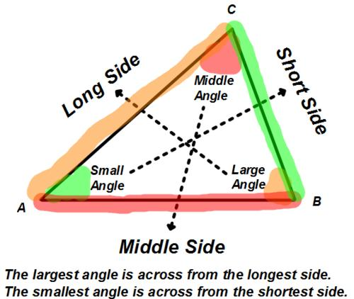
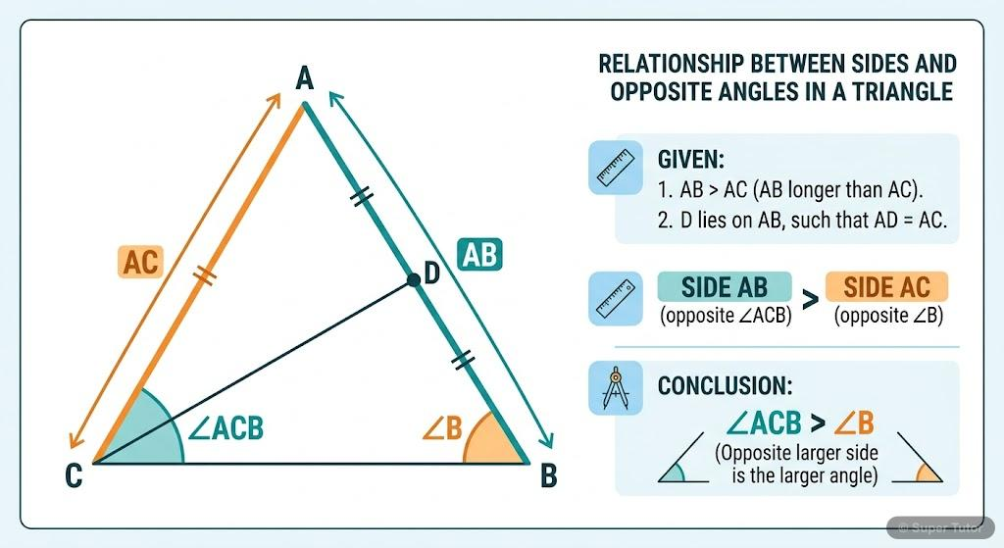
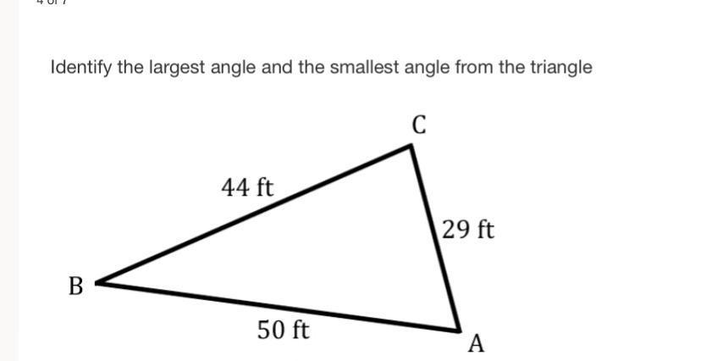
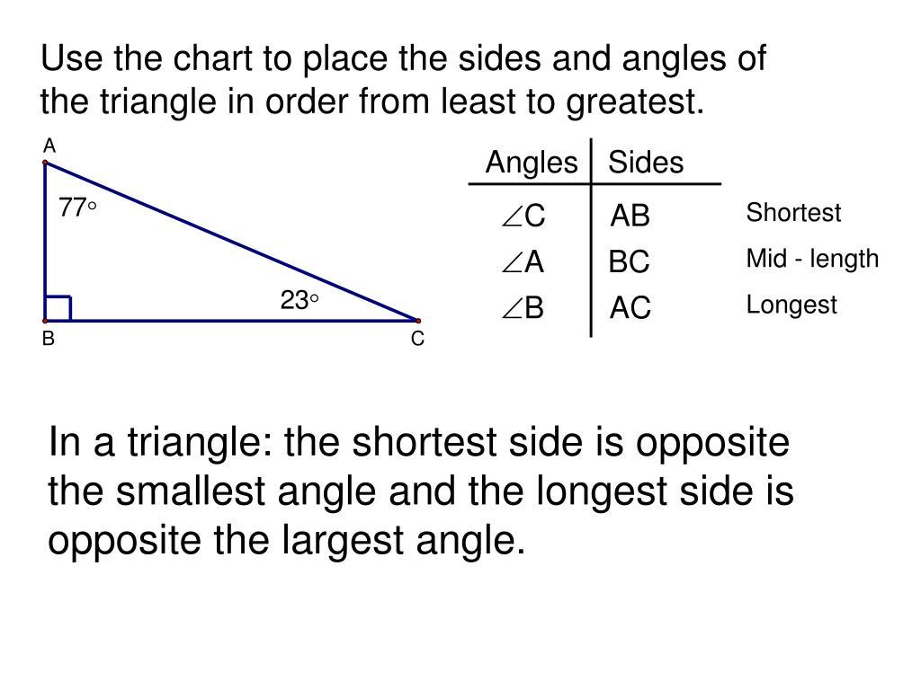
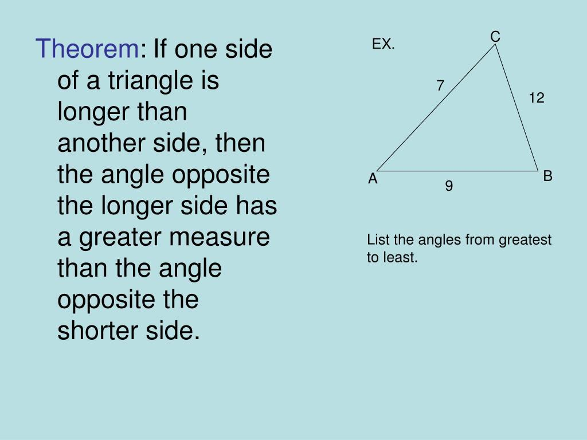

Triangle Inequality and Equilateral Triangles
# Source: AI Source: Provided by: [Data Path: Persons Table -> ID Column: 1, Name_En Column: Motasem Essam] -> From: [ChatGPT] on [7/25/2026]
For an equilateral triangle:
$$a=b=c$$
The Triangle Inequality becomes:
$$a+a>a$$
which simplifies to:
$$2a>a$$
This is true for every positive $a$.
Therefore, every set of three equal positive lengths can form an equilateral triangle.

Triangle Inequality and Isosceles Triangles
# Source: AI Source: Provided by: [Data Path: Persons Table -> ID Column: 1, Name_En Column: Motasem Essam] -> From: [ChatGPT] on [7/25/2026]
For an isosceles triangle:
$$a=a$$
and the third side is $b$.
The inequality requires:
$$a+a>b$$
so:
$$\boxed{b<2a}$$
Also:
$$a+b>a$$
which gives:
$$b>0$$
Thus:
$$\boxed{0<b<2a}$$
for positive lengths.

Triangle Inequality and Right Triangles
# Source: AI Source: Provided by: [Data Path: Persons Table -> ID Column: 1, Name_En Column: Motasem Essam] -> From: [ChatGPT] on [7/25/2026]
A right triangle satisfies the Triangle Inequality as well.
For example, a $3-4-5$triangle:
$$3+4>5 \\ 3+5>4 \\ 4+5>3$$
All conditions are satisfied.
The Pythagorean relationship:
$$3^{2}+4^{2}=5^{2}$$
is a different theorem from the Triangle Inequality Theorem.

Triangle Inequality vs Pythagorean Theorem
# Source: AI Source: Provided by: [Data Path: Persons Table -> ID Column: 1, Name_En Column: Motasem Essam] -> From: [ChatGPT] on [7/25/2026]
These two concepts should not be confused.
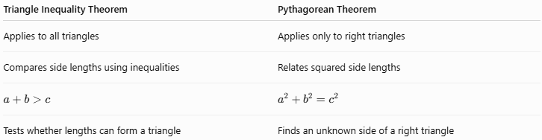
Triangle Inequality Theorem | Pythagorean Theorem
Applies to all triangles | Applies only to right triangles
Compares side lengths using inequalities | Relates squared side lengths
$$a+b>c$$ | $$a^{2}+b^{2}=c^{2}$$
Tests whether lengths can form a triangle | Finds an unknown side of a right triangle

Triangle Inequality in Coordinate Geometry
# Source: AI Source: Provided by: [Data Path: Persons Table -> ID Column: 1, Name_En Column: Motasem Essam] -> From: [ChatGPT] on [7/25/2026]
The theorem can also be understood using distances between points.
For three points $A,B,C$:
$$\boxed{AB+BC≥AC}$$
This is the triangle inequality for distances.
Equality occurs only when the three points are collinear and $B$lies between $A$and $C$.
For a proper triangle:
$$\boxed{AB+BC>AC}$$
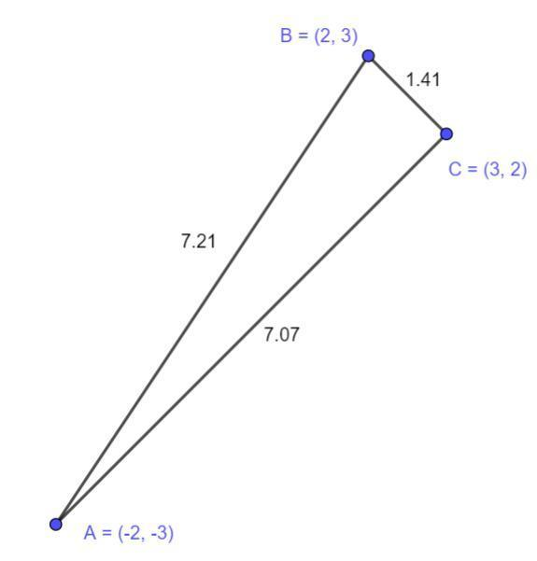
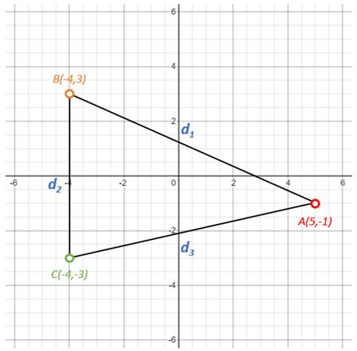
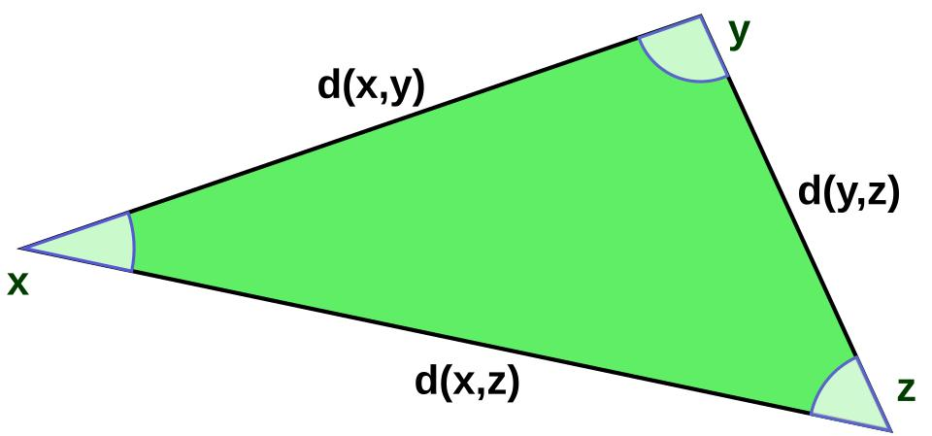
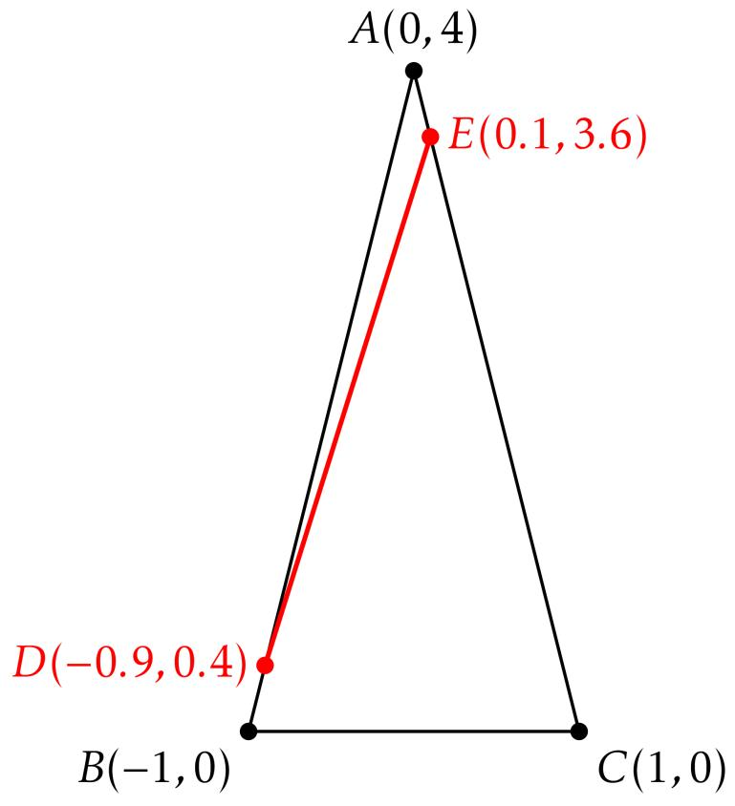

Geometric Interpretation
# Source: AI Source: Provided by: [Data Path: Persons Table -> ID Column: 1, Name_En Column: Motasem Essam] -> From: [ChatGPT] on [7/25/2026]
The Triangle Inequality can be understood as a shortest-path principle.
The direct path between two points is never longer than a path that goes through another point.
For points $A,B,C$:
$$\boxed{AC≤AB+BC}$$
If the points are not collinear:
$$\boxed{AC<AB+BC}$$
Therefore, a straight line is the shortest distance between two points.

Real-World Examples
# Source: AI Source: Provided by: [Data Path: Persons Table -> ID Column: 1, Name_En Column: Motasem Essam] -> From: [ChatGPT] on [7/25/2026]
The Triangle Inequality is relevant to:
- Construction.
- Structural engineering.
- Surveying.
- Architecture.
- Navigation.
- GPS systems.
- Road planning.
- Computer graphics.
- CAD.
- Robotics.
For example, if three measured distances are supposed to connect three locations and form a triangle, the measurements must satisfy the Triangle Inequality.
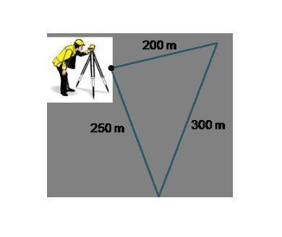
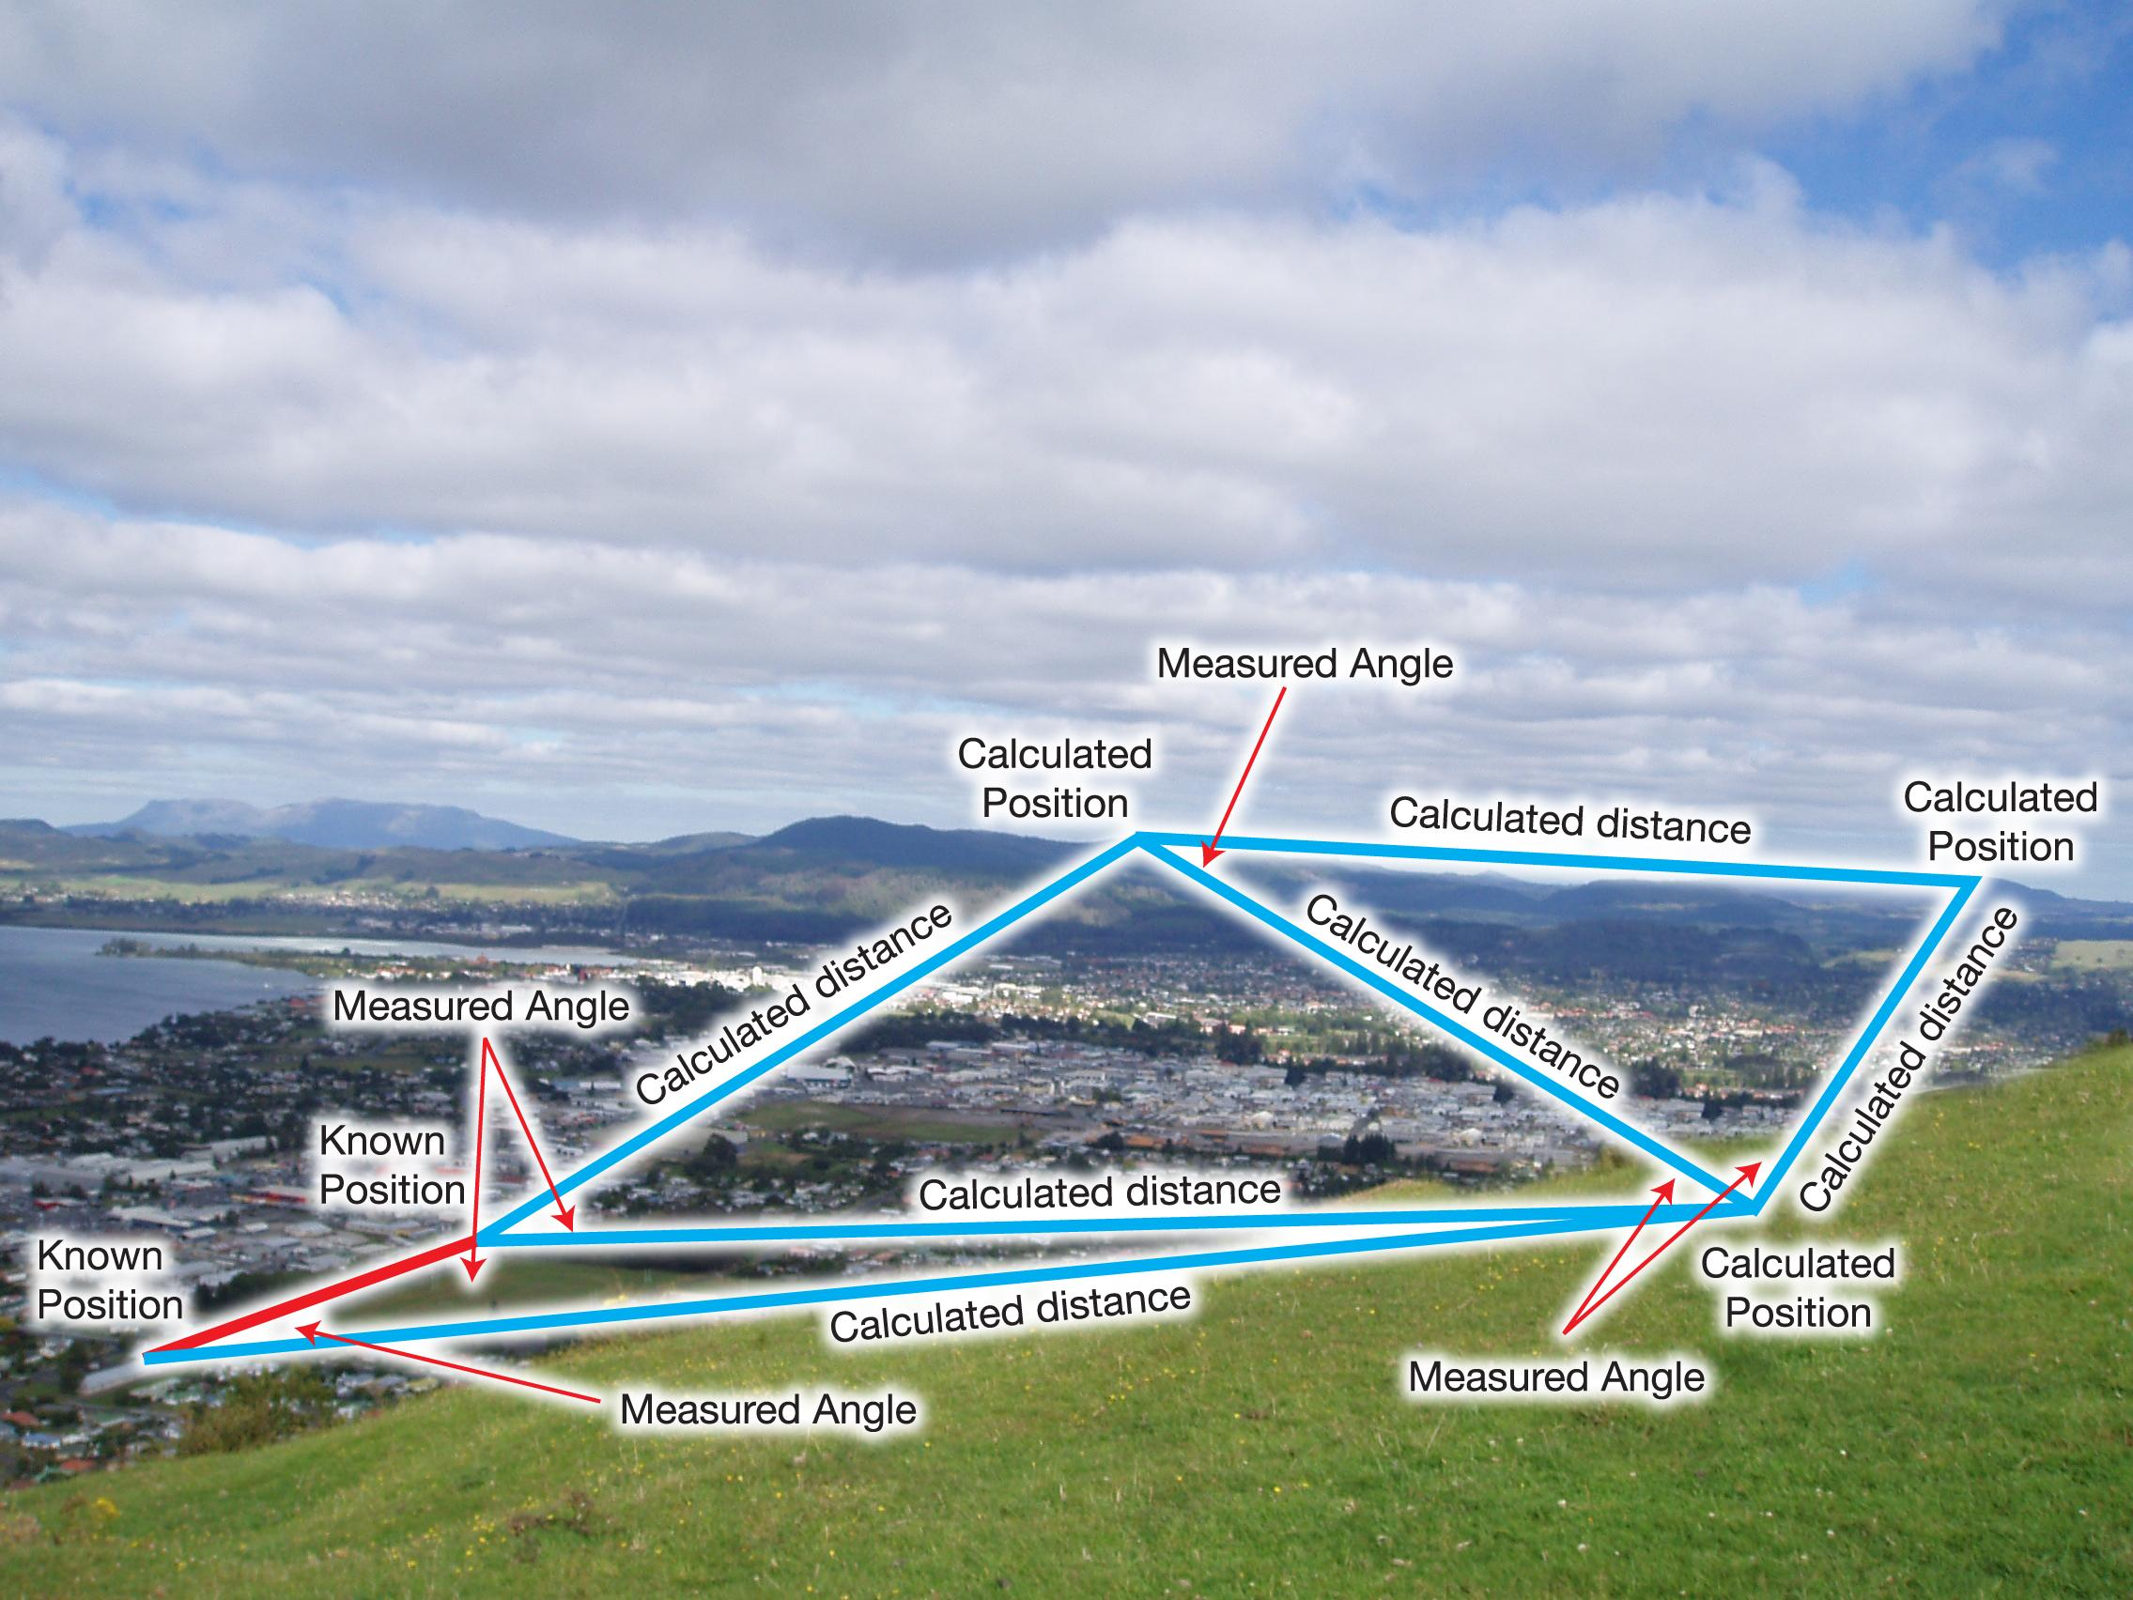
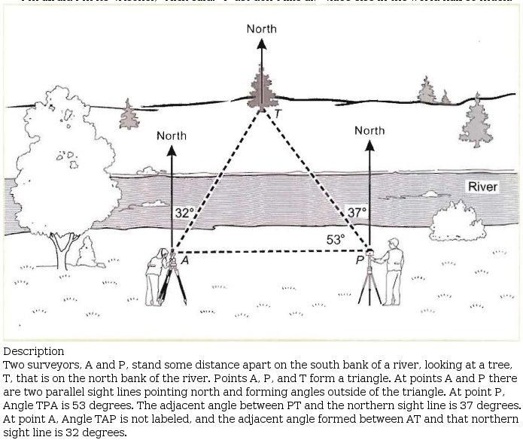

Applications
# Source: AI Source: Provided by: [Data Path: Persons Table -> ID Column: 1, Name_En Column: Motasem Essam] -> From: [ChatGPT] on [7/25/2026]
The Triangle Inequality Theorem is important in:
- Plane Geometry
- Triangle Geometry
- Coordinate Geometry
- Euclidean Geometry
- Trigonometry
- Surveying
- Engineering
- Architecture
- Computer Graphics
- CAD
- Robotics

Advantages
# Source: AI Source: Provided by: [Data Path: Persons Table -> ID Column: 1, Name_En Column: Motasem Essam] -> From: [ChatGPT] on [7/25/2026]
Studying the Triangle Inequality Theorem helps to:
- Determine whether three lengths can form a triangle.
- Find possible values of unknown sides.
- Establish limits on side lengths.
- Understand relationships between sides.
- Analyze geometric constructions.
- Solve coordinate geometry problems.
- Verify measurements.

Limitations
# Source: AI Source: Provided by: [Data Path: Persons Table -> ID Column: 1, Name_En Column: Motasem Essam] -> From: [ChatGPT] on [7/25/2026]
The Triangle Inequality Theorem:
- Applies to valid triangle side lengths.
- Requires positive side lengths.
- Uses strict inequalities for proper triangles.
- Does not determine the exact shape of a triangle by itself.
- Does not determine the exact angles from three arbitrary inequalities.

Comparison with Related Concepts
# Source: AI Source: Provided by: [Data Path: Persons Table -> ID Column: 1, Name_En Column: Motasem Essam] -> From: [ChatGPT] on [7/25/2026]
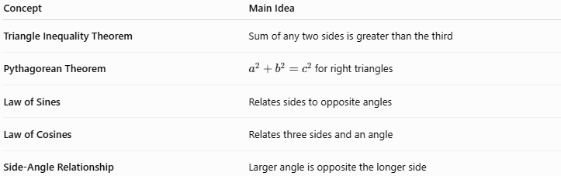
Concept | Main Idea
Triangle Inequality Theorem | Sum of any two sides is greater than the third
Pythagorean Theorem | $a^{2}+b^{2}=c^{2}$ for right triangles
Law of Sines | Relates sides to opposite angles
Law of Cosines | Relates three sides and an angle
Side-Angle Relationship | Larger angle is opposite the longer side

Key Points
# Source: AI Source: Provided by: [Data Path: Persons Table -> ID Column: 1, Name_En Column: Motasem Essam] -> From: [ChatGPT] on [7/25/2026]
- The Triangle Inequality Theorem states:
$$\boxed{a+b>c} \\ \boxed{a+c>b} \\ \boxed{b+c>a}$$
- All three side lengths must be positive.
- If two sides are $a$and $b$, the third side $c$must satisfy:
$$\boxed{∣a-b∣<c<a+b}$$
- If:
$$a+b=c$$
the figure is degenerate and is not a proper triangle.
- The longest side is opposite the largest angle.
- The shortest side is opposite the smallest angle.
- The theorem applies to every proper triangle, not only right triangles.

Conclusion
# Source: AI Source: Provided by: [Data Path: Persons Table -> ID Column: 1, Name_En Column: Motasem Essam] -> From: [ChatGPT] on [7/25/2026]
The Triangle Inequality Theorem establishes the fundamental relationship between the side lengths of a triangle. The sum of the lengths of any two sides must always be greater than the length of the third side:
$$\boxed{a+b>c, a+c>b, b+c>a}$$
When two sides are known, the possible range of the third side can be expressed as:
$$\boxed{∣a-b∣<c<a+b}$$
This theorem provides a simple but powerful way to determine whether given lengths can form a triangle and to establish bounds for unknown sides. It is fundamental to plane geometry, coordinate geometry, surveying, engineering, architecture, CAD, computer graphics, and many other applications.

